EXP 01 – P.Malreddy (192372015)
Use Figma to create an interactive diagram illustrating the components of a basic cellular system.

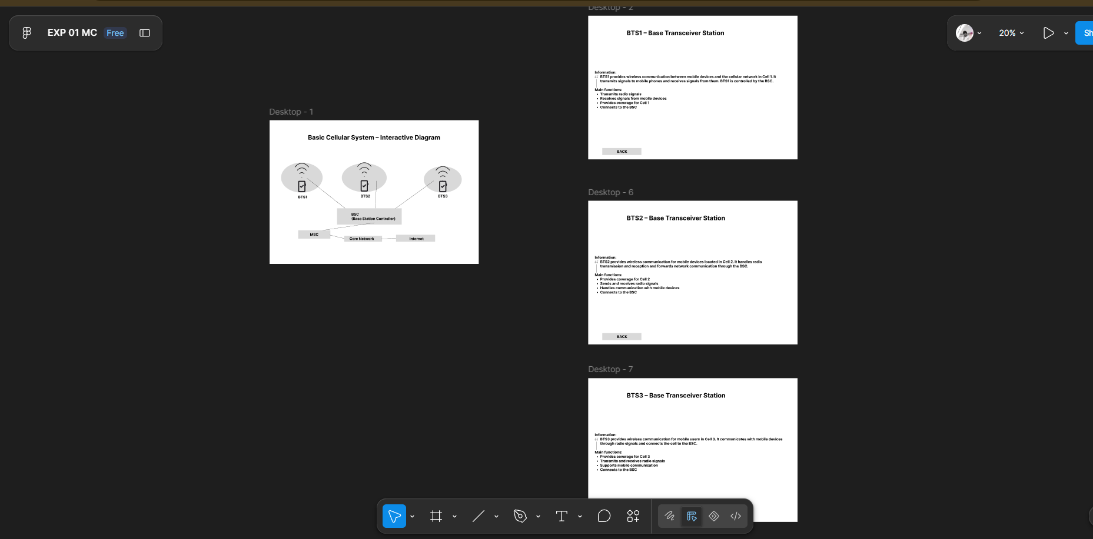

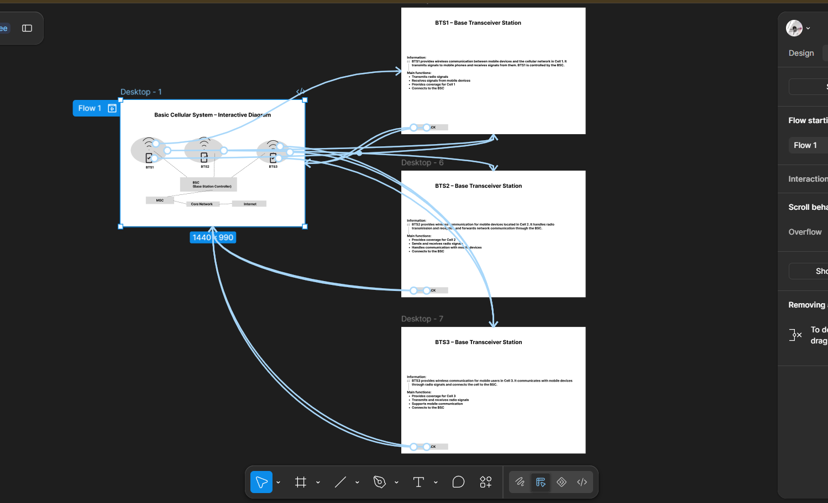
https://www.figma.com/design/bRCAU63yIJBH2s03TRfNxv/EXP-01-MC?node-id=1-2&t=Amd6ZmnRIRUXmm1W-0

